Data Annotation Platform
Solution Architecture Document

Version: 1.0
Date: February 7, 2026
Prepared by: Solution Architect / Tech Lead
Status: Technical Reference
Classification: Confidential

Table of Contents
1. Architecture Principles & Constraints
2. System Context (C4 Level 1)
3. Container Architecture (C4 Level 2)
4. Infrastructure Architecture (AWS)
5. Data Architecture
6. API Architecture
7. Frontend Architecture
8. Schema-Driven Task UI Engine
9. Pipeline Engine — Deep Dive
10. Queue & Claim Locking — Deep Dive
11. Media Handling — Upload, Storage & Rendering
12. Authentication & Authorization
13. Security Architecture
14. Performance & Scalability
15. Background Job Architecture
16. Logging, Audit & Observability
17. CI/CD & Deployment Architecture
18. Disaster Recovery & Data Integrity

1. Architecture Principles & Constraints

1.1 Design Principles
# | Principle | Rationale
P1 | PostgreSQL is the source of truth | All transactional state lives in PG. Redis is read-cache only. If Redis goes down, system is slower but never incorrect.
P2 | Schema-driven everything | Task UIs, validation, pipeline stages — all driven by config, not code. Zero deployments for new question types.
P3 | Soft delete everywhere | No record is physically removed. All entities have deleted_at. Supports audit trails, recovery, compliance.
P4 | Fail-safe claim locking | A rater can never see a task another rater is working on. Failures result in "try again", never double assignment.
P5 | Strict RBAC boundary | Customers cannot see ops. Raters cannot see ops tools. Enforced server-side. Separate frontend apps per persona.
P6 | Horizontal scalability | API layer is stateless. Any instance handles any request. Session state in Redis. ECS auto-scaling without sticky sessions.
P7 | Minimal cross-database transactions | PG and MongoDB are never in a shared transaction. PG writes are source of truth; Mongo follows.

1.2 Hard Constraints (Client-Mandated)
Constraint | Requirement
Backend | Node.js + Express + TypeScript
Frontend | React + TypeScript + Tailwind CSS
Relational DB | PostgreSQL (Amazon RDS)
Document DB | MongoDB-compatible (Amazon DocumentDB)
Object Storage | Amazon S3
Auth (Phase 2) | Okta SSO (OAuth2 PKCE) — client manages tenants
CI/CD | GitHub Actions
Monitoring | Datadog
Infrastructure | AWS (dev / staging / prod)
APIs | REST + OpenAPI/Swagger
IP Ownership | Client exclusive (work-for-hire)

1.3 Scale Targets (Client-Confirmed)
Metric | Target
Daily task volume | 100,000 avg / 150,000 peak
Concurrent rater sessions | 500 avg / 800 peak
Max media file size | 500 MB per asset
Max batch upload size | No limit (streaming required)
API response time (p95) | < 300ms
UI load time (p95) | < 2 seconds
Claim collision rate | 0% (deterministic locking)
Data retention | Configurable (client DevOps manages)

2. System Context (C4 Level 1)
This diagram shows the Data Annotation Platform and all external systems and users it interacts with. The platform sits at the center with three portals (Ops, Rater, Customer) and connects outward to S3, Okta, Datadog, and GitHub Actions.
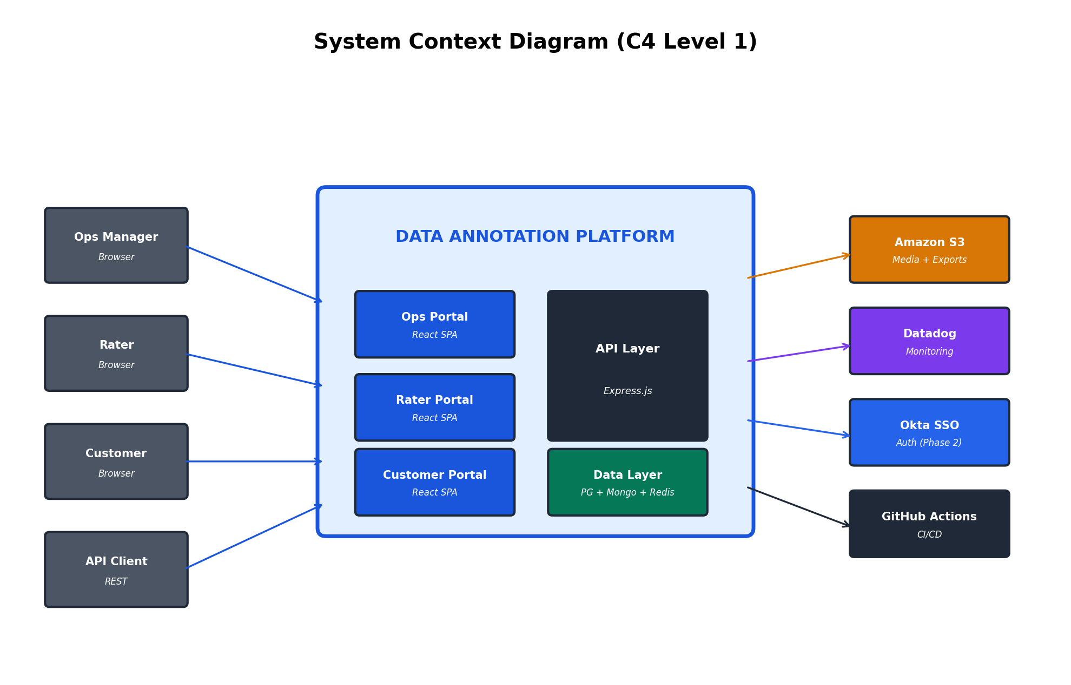

External System Interactions
System | Direction | Purpose | Protocol
Amazon S3 | Read/Write | Store task media files, export ZIPs, upload staging | S3 SDK + presigned URLs
Okta (Phase 2) | Read | OAuth2 authentication, user provisioning, session validation | OAuth2 PKCE, HTTPS
Datadog | Write | Application logs, metrics, traces, dashboards, alerting | Datadog Agent + APM SDK
External API | Read/Write | Task upload (ingest), result retrieval (export) | HTTPS + Bearer token
GitHub Actions | Write → Deploy | CI/CD: build, test, deploy container images to ECS | Docker push to ECR

3. Container Architecture (C4 Level 2)

3.1 Monorepo Structure
The codebase is organized as a Turborepo monorepo with separate apps for each deployable service and shared packages for types, UI components, the schema engine, and the pipeline engine.
annotation-platform/ # Turborepo root
├── apps/
│ ├── api/ # Node.js/Express REST API
│ │ ├── src/modules/ # Feature modules (auth, task, queue, etc.)
│ │ ├── src/middleware/ # Auth, RBAC, error handling, rate limit
│ │ ├── src/jobs/ # Background job definitions (BullMQ)
│ │ ├── prisma/ # PostgreSQL schema + migrations
│ │ └── Dockerfile
│ ├── web-ops/ # Ops Portal (React)
│ ├── web-rater/ # Rater/Reviewer Portal (React)
│ ├── web-customer/ # Customer Portal (React)
│ └── worker/ # Background job processor (BullMQ)
├── packages/
│ ├── shared-types/ # TypeScript types shared across apps
│ ├── ui/ # Shared React component library (shadcn/ui)
│ ├── schema-engine/ # JSON Schema → Form validation + rendering
│ └── pipeline-engine/ # Pipeline state machine
├── docker-compose.yml # Local dev (PG + Mongo + Redis + MinIO)
└── .github/workflows/ # CI/CD pipelines

3.2 Container Diagram
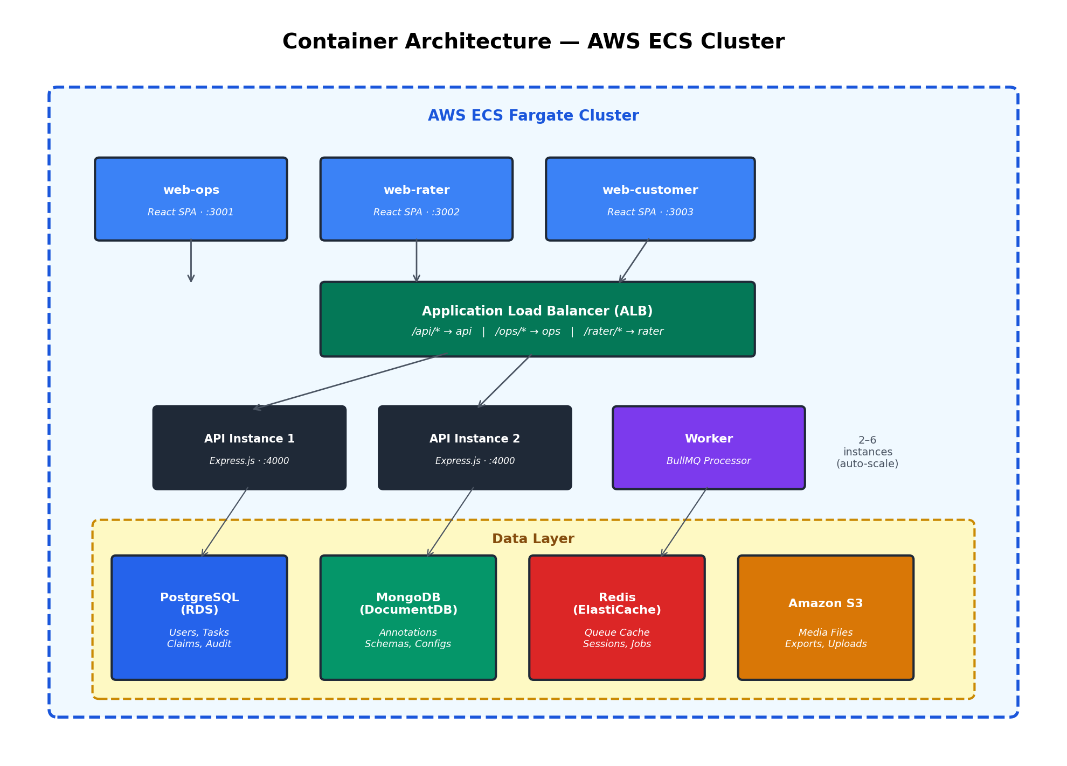

3.3 Service Responsibilities
Service | Runtime | Responsibilities | Scaling
api | ECS Fargate (Node.js) | REST API, auth, business logic, claim locking, pipeline transitions | Horizontal: 2-6 instances (CPU/connections)
worker | ECS Fargate (Node.js) | Background jobs: bulk upload, export, claim cleanup, audit cleanup | 1-3 instances based on queue depth
web-ops | ECS Fargate (Nginx) | Serves Ops Portal React SPA | 1-2 instances
web-rater | ECS Fargate (Nginx) | Serves Rater Portal React SPA | 1-2 instances
web-customer | ECS Fargate (Nginx) | Serves Customer Portal React SPA | 1 instance

4. Infrastructure Architecture (AWS)

4.1 Network Architecture
The VPC uses a three-tier subnet model: Public subnets host the ALB and NAT Gateway, Private subnets run ECS Fargate tasks, and Data subnets isolate all databases with zero internet access. S3 is accessed via a VPC Gateway Endpoint.
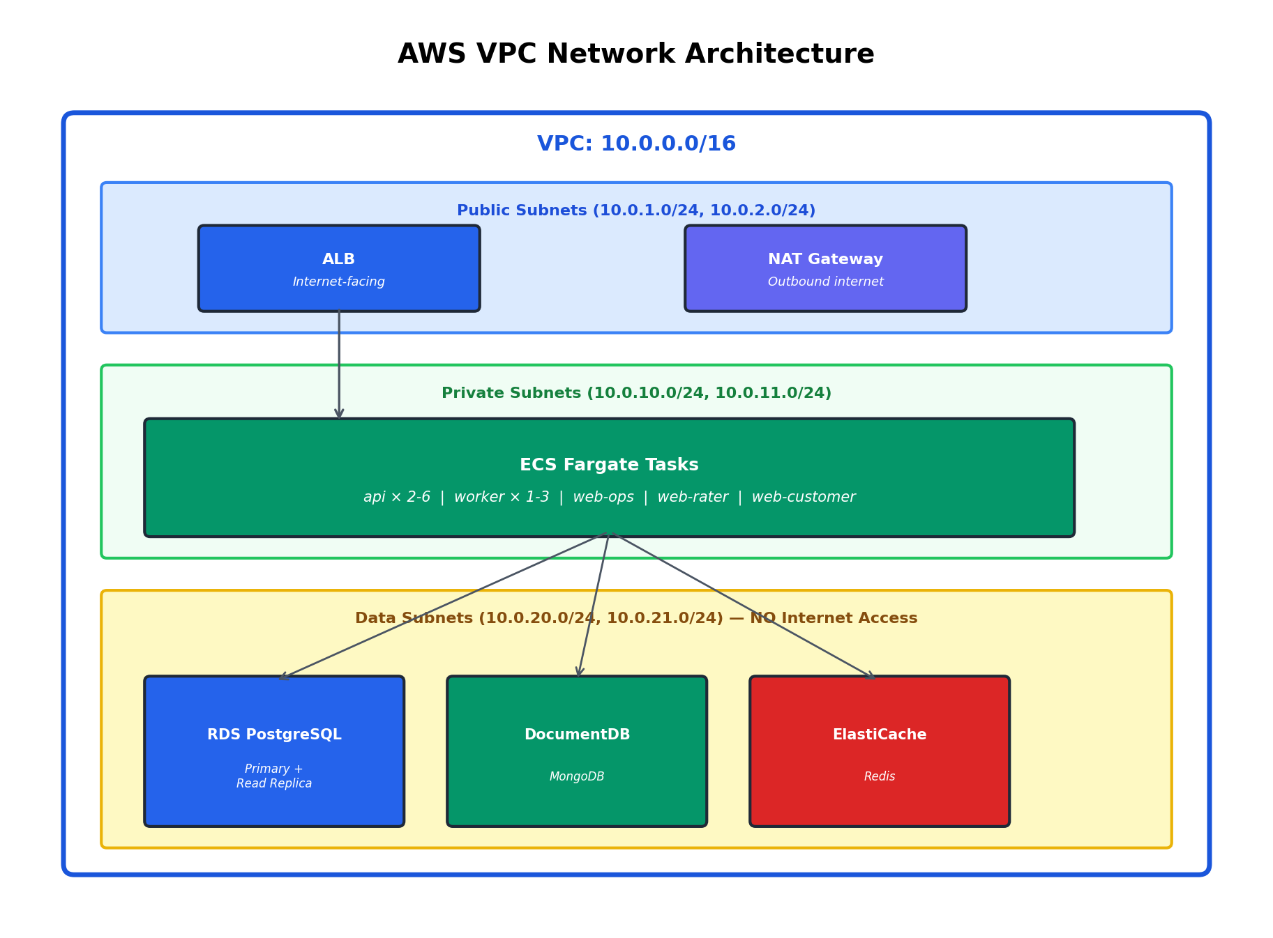

4.2 Environment Matrix
Aspect | Dev | Staging | Production
RDS Instance | db.t3.medium (single) | db.r6g.large (single) | db.r6g.xlarge + read replica
DocumentDB | db.t3.medium (single) | db.r6g.large (single) | db.r6g.xlarge
ElastiCache | cache.t3.small | cache.r6g.medium | cache.r6g.large
ECS API | 1 task (0.5 vCPU / 1 GB) | 2 tasks (1 vCPU / 2 GB) | 2-6 tasks (2 vCPU / 4 GB) + auto-scale
ECS Worker | 1 task | 1 task | 1-3 tasks + auto-scale
S3 | Shared buckets | Separate buckets | Separate + versioning
Multi-AZ | No | No | Yes (RDS, DocumentDB, ElastiCache)
Backups | None | Daily (7-day) | Continuous (35-day) + PITR
Deploy Trigger | Push to develop | Push to main | Manual (approval required)

5. Data Architecture

5.1 Database Boundary — What Goes Where
The storage strategy follows a simple rule of thumb:
- If it needs Referential integrity or transactions -> PostgreSQL
- If it's Schema-flexible or deeply nested JSON -> MongoDB
- If it needs Sub-millisecond reads or ephemeral state -> Redis
- If it's A file or binary blob -> S3
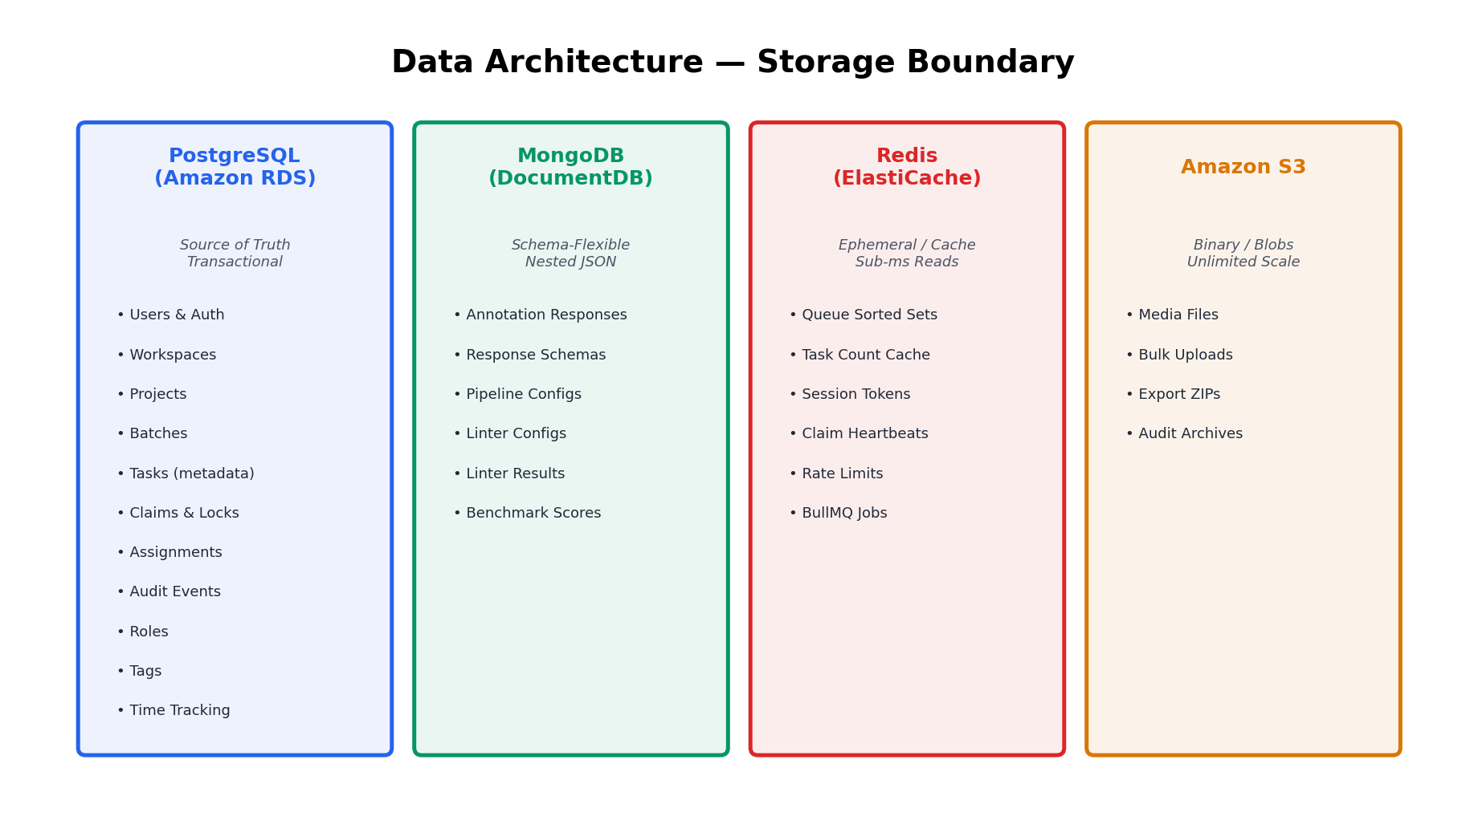
PostgreSQL (Amazon RDS) | MongoDB (Amazon DocumentDB) | Redis (ElastiCache) | S3
Users & auth | Annotation responses | Queue ordered sets | Media files (img/audio/video)
Workspaces | Response schemas (JSON) | Task count caches | Bulk upload staging
Projects (metadata) | Pipeline configurations | Session tokens | Export ZIPs
Batches (metadata) | Linter configurations | Rate limit counters | Audit log archives
Tasks (metadata + status) | Linter execution results | Project config cache
Task claims & locks | UI schema definitions | Claim heartbeats
Assignments | Benchmark scores (detail) | BullMQ job queue
Audit events
User roles & permissions
Tags (task + rater)
Organizations & seats
Time tracking records

5.2 PostgreSQL Schema (ERD) — Full Definition
The complete PostgreSQL schema with all tables, columns, indexes, and foreign key relationships. All tables include deleted_at for soft delete per client confirmation.
-- ============================================================
-- CORE HIERARCHY: Workspace -> Project -> Batch -> Task
-- ============================================================

CREATE TABLE workspaces (
id UUID PRIMARY KEY DEFAULT gen_random_uuid(),
name VARCHAR(255) NOT NULL,
organization_id UUID REFERENCES organizations(id),
created_at TIMESTAMPTZ NOT NULL DEFAULT NOW(),
updated_at TIMESTAMPTZ NOT NULL DEFAULT NOW(),
deleted_at TIMESTAMPTZ -- soft delete
);

CREATE TABLE projects (
id UUID PRIMARY KEY DEFAULT gen_random_uuid(),
workspace_id UUID NOT NULL REFERENCES workspaces(id),
name VARCHAR(255) NOT NULL,
description TEXT,
status VARCHAR(50) NOT NULL DEFAULT 'active', -- active, archived
pipeline_config_id VARCHAR(100), -- ref to MongoDB pipeline doc
schema_config_id VARCHAR(100), -- ref to MongoDB schema doc
created_by UUID REFERENCES users(id),
created_at TIMESTAMPTZ NOT NULL DEFAULT NOW(),
updated_at TIMESTAMPTZ NOT NULL DEFAULT NOW(),
deleted_at TIMESTAMPTZ
);
CREATE INDEX idx_projects_workspace ON projects(workspace_id) WHERE deleted_at IS NULL;

CREATE TABLE batches (
id UUID PRIMARY KEY DEFAULT gen_random_uuid(),
project_id UUID NOT NULL REFERENCES projects(id),
name VARCHAR(255) NOT NULL,
status VARCHAR(50) NOT NULL DEFAULT 'active',
task_count INT NOT NULL DEFAULT 0, -- denormalized counter
schema_version_id VARCHAR(100), -- override project schema
created_by UUID REFERENCES users(id),
created_at TIMESTAMPTZ NOT NULL DEFAULT NOW(),
updated_at TIMESTAMPTZ NOT NULL DEFAULT NOW(),
deleted_at TIMESTAMPTZ
);
CREATE INDEX idx_batches_project ON batches(project_id) WHERE deleted_at IS NULL;

CREATE TABLE tasks (
id UUID PRIMARY KEY DEFAULT gen_random_uuid(),
batch_id UUID NOT NULL REFERENCES batches(id),
project_id UUID NOT NULL REFERENCES projects(id), -- denormalized for fast query
external_id VARCHAR(255), -- client's original task ID
status VARCHAR(50) NOT NULL DEFAULT 'pending',
pipeline_stage VARCHAR(100) NOT NULL DEFAULT 'l1',
priority INT NOT NULL DEFAULT 0, -- higher = served first
media_keys JSONB, -- S3 keys for task files
task_data JSONB, -- structured task input
schema_version_id VARCHAR(100), -- which response schema applies
uploaded_at TIMESTAMPTZ NOT NULL DEFAULT NOW(), -- FIFO ordering key
created_at TIMESTAMPTZ NOT NULL DEFAULT NOW(),
updated_at TIMESTAMPTZ NOT NULL DEFAULT NOW(),
deleted_at TIMESTAMPTZ
);
-- Critical indexes for queue performance at 100K tasks/day
CREATE INDEX idx_tasks_queue ON tasks(batch_id, pipeline_stage, status, uploaded_at)
WHERE deleted_at IS NULL AND status = 'pending';
CREATE INDEX idx_tasks_project_status ON tasks(project_id, status) WHERE deleted_at IS NULL;
CREATE INDEX idx_tasks_batch ON tasks(batch_id) WHERE deleted_at IS NULL;
CREATE INDEX idx_tasks_external ON tasks(external_id) WHERE external_id IS NOT NULL;
-- ============================================================
-- CLAIM LOCKING: The most critical table for concurrency
-- ============================================================

CREATE TABLE task_claims (
id UUID PRIMARY KEY DEFAULT gen_random_uuid(),
task_id UUID NOT NULL REFERENCES tasks(id),
user_id UUID NOT NULL REFERENCES users(id),
pipeline_stage VARCHAR(100) NOT NULL,
status VARCHAR(50) NOT NULL DEFAULT 'active', -- active, completed, expired, released
claimed_at TIMESTAMPTZ NOT NULL DEFAULT NOW(),
last_heartbeat TIMESTAMPTZ NOT NULL DEFAULT NOW(),
completed_at TIMESTAMPTZ,
expires_at TIMESTAMPTZ NOT NULL, -- hard deadline
created_at TIMESTAMPTZ NOT NULL DEFAULT NOW()
);
-- Ensure one active claim per task per stage
CREATE UNIQUE INDEX idx_claims_active ON task_claims(task_id, pipeline_stage)
WHERE status = 'active';
CREATE INDEX idx_claims_expired ON task_claims(status, last_heartbeat)
WHERE status = 'active';
CREATE INDEX idx_claims_user ON task_claims(user_id, status);

-- ============================================================
-- ASSIGNMENTS: Who is allowed to work on what
-- ============================================================

CREATE TABLE assignments (
id UUID PRIMARY KEY DEFAULT gen_random_uuid(),
user_id UUID NOT NULL REFERENCES users(id),
project_id UUID REFERENCES projects(id), -- project-level assignment
batch_id UUID REFERENCES batches(id), -- batch-level assignment
pipeline_stage VARCHAR(100), -- optional: restrict to stage
assigned_by UUID REFERENCES users(id),
created_at TIMESTAMPTZ NOT NULL DEFAULT NOW(),
deleted_at TIMESTAMPTZ
);
CREATE INDEX idx_assignments_user ON assignments(user_id) WHERE deleted_at IS NULL;
CREATE INDEX idx_assignments_batch ON assignments(batch_id) WHERE deleted_at IS NULL;
-- ============================================================
-- USERS, AUTH & RBAC
-- ============================================================

CREATE TABLE organizations (
id UUID PRIMARY KEY DEFAULT gen_random_uuid(),
name VARCHAR(255) NOT NULL,
plan_tier VARCHAR(50) DEFAULT 'standard',
max_seats INT DEFAULT 10,
api_key VARCHAR(255) UNIQUE,
created_at TIMESTAMPTZ NOT NULL DEFAULT NOW(),
deleted_at TIMESTAMPTZ
);

CREATE TABLE users (
id UUID PRIMARY KEY DEFAULT gen_random_uuid(),
email VARCHAR(255) UNIQUE NOT NULL,
password_hash VARCHAR(255), -- NULL when using Okta SSO
name VARCHAR(255) NOT NULL,
okta_id VARCHAR(255), -- populated in Phase 2
organization_id UUID REFERENCES organizations(id),
is_internal BOOLEAN NOT NULL DEFAULT false,
status VARCHAR(50) NOT NULL DEFAULT 'active',
created_at TIMESTAMPTZ NOT NULL DEFAULT NOW(),
updated_at TIMESTAMPTZ NOT NULL DEFAULT NOW(),
deleted_at TIMESTAMPTZ
);
CREATE INDEX idx_users_email ON users(email) WHERE deleted_at IS NULL;
CREATE INDEX idx_users_org ON users(organization_id) WHERE deleted_at IS NULL;

CREATE TABLE user_roles (
id UUID PRIMARY KEY DEFAULT gen_random_uuid(),
user_id UUID NOT NULL REFERENCES users(id),
role VARCHAR(50) NOT NULL, -- admin, ops, rater, reviewer, customer
scope_type VARCHAR(50) NOT NULL DEFAULT 'global', -- global, workspace, project
scope_id UUID, -- NULL for global
rater_level INT, -- rater qualification level per project
granted_by UUID REFERENCES users(id),
created_at TIMESTAMPTZ NOT NULL DEFAULT NOW(),
deleted_at TIMESTAMPTZ
);
CREATE INDEX idx_user_roles_user ON user_roles(user_id) WHERE deleted_at IS NULL;
-- ============================================================
-- TAGS, TIME TRACKING & AUDIT LOG
-- ============================================================

CREATE TABLE tags (
id UUID PRIMARY KEY DEFAULT gen_random_uuid(),
name VARCHAR(100) NOT NULL,
entity_type VARCHAR(50) NOT NULL, -- 'task' or 'user'
entity_id UUID NOT NULL,
created_by UUID REFERENCES users(id),
created_at TIMESTAMPTZ NOT NULL DEFAULT NOW()
);
CREATE INDEX idx_tags_entity ON tags(entity_type, entity_id);
CREATE INDEX idx_tags_name ON tags(name, entity_type);

CREATE TABLE time_entries (
id UUID PRIMARY KEY DEFAULT gen_random_uuid(),
task_id UUID NOT NULL REFERENCES tasks(id),
user_id UUID NOT NULL REFERENCES users(id),
claim_id UUID NOT NULL REFERENCES task_claims(id),
active_seconds INT NOT NULL, -- active time (idle excluded)
total_seconds INT NOT NULL, -- wall clock time
started_at TIMESTAMPTZ NOT NULL,
ended_at TIMESTAMPTZ NOT NULL,
created_at TIMESTAMPTZ NOT NULL DEFAULT NOW()
);
CREATE INDEX idx_time_user ON time_entries(user_id);
CREATE INDEX idx_time_task ON time_entries(task_id);

CREATE TABLE audit_events (
id UUID PRIMARY KEY DEFAULT gen_random_uuid(),
event_type VARCHAR(100) NOT NULL,
actor_id UUID REFERENCES users(id),
actor_email VARCHAR(255),
resource_type VARCHAR(100),
resource_id UUID,
details JSONB, -- event-specific payload
ip_address INET,
impersonator_id UUID, -- non-null if impersonating
created_at TIMESTAMPTZ NOT NULL DEFAULT NOW()
);
-- Partitioned by month for fast retention-based cleanup
CREATE INDEX idx_audit_type ON audit_events(event_type, created_at);
CREATE INDEX idx_audit_actor ON audit_events(actor_id, created_at);
CREATE INDEX idx_audit_resource ON audit_events(resource_type, resource_id);

5.3 MongoDB Schemas — Full Document Definitions

Annotations Collection
Stores the actual annotation data. Shape varies per project. Each annotation references PG task, user, and claim.
// Collection: annotations
{
_id: ObjectId,
taskId: "uuid-string", // references PG tasks.id
userId: "uuid-string", // references PG users.id
claimId: "uuid-string", // references PG task_claims.id
pipelineStage: "l1", // which stage this was submitted at
schemaVersionId: "schema_v3", // which schema was used

// The actual annotation data -- shape varies per project
response: {
overall_quality: "good",
turns: [
{ turn_rating: "helpful", turn_feedback: "Clear explanation" },
{ turn_rating: "not_helpful", turn_feedback: "Off topic" }
],
reviewer_notes: null // null until review stage
},

// Quality metadata
linterResults: [
{ linterId: "response_length", status: "pass", message: null },
{ linterId: "required_fields", status: "pass", message: null }
],

// Timing
activeTimeSeconds: 165,
submittedAt: ISODate("2026-03-15T10:30:00Z"),
createdAt: ISODate("2026-03-15T10:30:00Z")
}
// Indexes:
// db.annotations.createIndex({ taskId: 1, pipelineStage: 1 })
// db.annotations.createIndex({ userId: 1, createdAt: -1 })

Response Schemas Collection
Defines what the Task UI renders per pipeline stage using JSON Schema with x-ui-* extensions for conditional logic, repeaters, and visibility rules.
// Collection: response_schemas
{
_id: ObjectId,
schemaId: "schema_v3",
projectId: "uuid-string",
version: 3,
isActive: true,

stages: {
"l1": {
type: "object",
properties: {
overall_quality: {
type: "string",
enum: ["excellent", "good", "fair", "poor"],
"x-ui-component": "single-select",
"x-ui-label": "Overall Quality",
"x-ui-order": 1,
"x-ui-visibility": ["l1", "review"],
"x-ui-required": true
},
rejection_reason: {
type: "string",
"x-ui-component": "free-text",
"x-ui-label": "Reason for Rejection",
"x-ui-order": 2,
"x-ui-condition": { // CONDITIONAL
"field": "overall_quality",
"operator": "in",
"value": ["fair", "poor"]
},
"x-ui-rows": 3
},
turns: {
type: "array",
"x-ui-component": "repeater",
"x-ui-label": "Per-Turn Ratings",
"x-ui-order": 3,
"x-ui-repeat-source": "task.data.conversation_turns",
"x-ui-repeat-label-field": "content",
items: {
type: "object",
properties: {
turn_rating: {
type: "string",
enum: ["helpful", "not_helpful", "neutral"],
"x-ui-component": "single-select"
},
turn_feedback: {
type: "string",
"x-ui-component": "free-text",
"x-ui-rows": 2
}
},
required: ["turn_rating"]
}
}
},
required: ["overall_quality"]
},
"review": {
type: "object",
properties: {
decision: {
type: "string",
enum: ["approve", "reject", "revise"],
"x-ui-component": "single-select",
"x-ui-required": true
},
reviewer_feedback: {
type: "string",
"x-ui-component": "free-text",
"x-ui-condition": {
"field": "decision",
"operator": "in",
"value": ["reject", "revise"]
}
}
},
required: ["decision"]
}
},
createdAt: ISODate("2026-03-01T00:00:00Z"),
createdBy: "uuid-string"
}

Pipeline Configs Collection
// Collection: pipeline_configs
{
_id: ObjectId,
configId: "pipeline_v2",
projectId: "uuid-string",
version: 2,
isActive: true,

stages: [
{ id: "l1", name: "Annotation", type: "annotation", order: 1,
assignableRoles: ["rater"], autoAdvance: true, consensusN: 1 },
{ id: "l2", name: "Senior Annotation", type: "annotation", order: 2,
assignableRoles: ["senior_rater"], autoAdvance: true, consensusN: 1 },
{ id: "review", name: "QA Review", type: "review", order: 3,
assignableRoles: ["reviewer"], autoAdvance: true, consensusN: 1 },
{ id: "hold", name: "Hold", type: "system", order: 98 },
{ id: "archive", name: "Archive", type: "system", order: 99 },
{ id: "done", name: "Done", type: "terminal", order: 100 }
],

transitions: [
{ from: "l1", to: ["l2", "hold", "archive"] },
{ from: "l2", to: ["review", "hold", "archive"] },
{ from: "review", to: ["done", "l1", "hold"] }, // reject -> back to l1
{ from: "hold", to: ["l1", "l2", "review", "archive"] },
{ from: "done", to: ["delivered"] }
],
createdAt: ISODate("2026-03-01T00:00:00Z")
}

Linter Configs Collection
// Collection: linter_configs
{
_id: ObjectId,
projectId: "uuid-string",
linters: [
{
linterId: "response_length",
enabled: true,
mode: "blocking", // "blocking" or "warning"
params: { min_length: 50, max_length: 5000 },
appliesTo: ["l1", "l2"]
},
{
linterId: "required_fields",
enabled: true,
mode: "blocking",
params: {},
appliesTo: ["l1", "l2", "review"]
},
{
linterId: "response_time",
enabled: true,
mode: "warning",
params: { min_seconds: 10 },
appliesTo: ["l1"]
}
]
}

5.4 Redis Data Structures — Full Commands
# ============================================================
# QUEUE CACHE -- Sorted set for fast FIFO serving
# ============================================================
# Key: queue:{batch_id}:{pipeline_stage}
# Score: uploaded_at timestamp (ms) | Member: task_id
ZADD queue:batch_042:l1 1709294400000 "task_001"
ZADD queue:batch_042:l1 1709294401000 "task_002"
ZADD queue:batch_042:l1 1709294402000 "task_003"

# Pop next eligible task (lowest score = oldest = FIFO)
# Note: actual claim still goes to PostgreSQL. Redis is a fast pre-filter.
ZRANGEBYSCORE queue:batch_042:l1 -inf +inf LIMIT 0 1

# Remove from queue after claim
ZREM queue:batch_042:l1 "task_001"

# ============================================================
# TASK COUNTS -- Atomic counters per status
# ============================================================
INCR counts:proj_123:pending # 4521
INCR counts:proj_123:claimed # 89
INCR counts:proj_123:done # 12340
# Used by dashboard / Ops task list without running COUNT(*) on PG
HSET project_counts:proj_123 pending 4521 claimed 89 done 12340

# ============================================================
# SESSION STORE
# ============================================================
SET session:abc123 '{"userId":"u_001","role":"rater","exp":1709380800}' EX 3600

# ============================================================
# HEARTBEAT TRACKING
# ============================================================
SET heartbeat:claim_xyz 1709294500 EX 300 # expires in 5 min

# ============================================================
# RATE LIMITING -- Sliding window counter
# ============================================================
INCR ratelimit:1.2.3.4:/api/auth/login
EXPIRE ratelimit:1.2.3.4:/api/auth/login 60 # 60 second window

# ============================================================
# BULLMQ JOB QUEUES (uses Redis internally)
# ============================================================
# - Job storage and processing
# - Priority queues
# - Delayed jobs (claim cleanup runs every 60s)
# - Failed job retry with exponential backoff

6. API Architecture

6.1 API Design Conventions
Convention | Standard
Base URL | /api/v1/
Auth | Authorization: Bearer <JWT> (Phase 1) / Okta token (Phase 2)
Response format | { "data": {...}, "meta": {...} } for success
Error format | { "error": { "code": "NOT_FOUND", "message": "...", "details": [...] } }
Pagination | Cursor-based: ?cursor=xxx&limit=50 (default 50, max 200)
Filtering | ?status=pending&pipeline_stage=l1&tag=priority
Timestamps | ISO 8601 with timezone: 2026-03-15T10:30:00Z
IDs | UUID v4
Versioning | URL-based (/v1/). Breaking changes → /v2/

6.2 Core API Endpoints — Full Listing
# ============================================================
# AUTHENTICATION (auth module)
# ============================================================
POST /api/v1/auth/login # Email+password -> JWT
POST /api/v1/auth/logout # Invalidate session
GET /api/v1/auth/me # Current user profile
POST /api/v1/auth/refresh # Refresh JWT
POST /api/v1/auth/okta/callback # Phase 2: OAuth2 callback

# ============================================================
# WORKSPACES
# ============================================================
POST /api/v1/workspaces # Create workspace
GET /api/v1/workspaces # List workspaces
GET /api/v1/workspaces/:id # Get workspace detail
PATCH /api/v1/workspaces/:id # Update workspace

# ============================================================
# PROJECTS
# ============================================================
POST /api/v1/projects # Create project
GET /api/v1/projects # List projects (filterable by workspace)
GET /api/v1/projects/:id # Get project with pipeline + schema info
PATCH /api/v1/projects/:id # Update project
DELETE /api/v1/projects/:id # Soft delete
POST /api/v1/projects/:id/clone # Clone project config

# ============================================================
# BATCHES
# ============================================================
POST /api/v1/projects/:projectId/batches # Create batch
GET /api/v1/projects/:projectId/batches # List batches
GET /api/v1/batches/:id # Get batch with task counts
PATCH /api/v1/batches/:id # Update batch

# ============================================================
# TASKS
# ============================================================
POST /api/v1/batches/:batchId/tasks # Create single task
GET /api/v1/batches/:batchId/tasks # List tasks (paginated, filterable)
GET /api/v1/tasks/:id # Get task detail + media URLs
PATCH /api/v1/tasks/:id/status # Advance/hold/archive task

# ============================================================
# QUEUE & CLAIMING (The critical flow)
# ============================================================
POST /api/v1/queue/next # Claim next task (FIFO) -> task + claim_id
POST /api/v1/claims/:id/heartbeat # Heartbeat (keep claim alive)
POST /api/v1/claims/:id/release # Voluntarily release claim

# ============================================================
# ANNOTATIONS
# ============================================================
POST /api/v1/tasks/:taskId/annotations # Submit annotation (validates against schema)
GET /api/v1/tasks/:taskId/annotations # List annotations for task (reviewer view)
GET /api/v1/annotations/:id # Get annotation detail

# ============================================================
# ASSIGNMENTS
# ============================================================
POST /api/v1/assignments # Assign user(s) to project/batch
DELETE /api/v1/assignments/:id # Remove assignment
GET /api/v1/batches/:id/assignments # List assignments for batch
POST /api/v1/assignments/bulk # Mass assign by rater level

# ============================================================
# BULK UPLOAD (Background Job)
# ============================================================
POST /api/v1/batches/:id/upload # Upload NDJSON/CSV -> starts background job
GET /api/v1/upload-jobs/:jobId # Get upload job status + progress
GET /api/v1/upload-jobs/:jobId/errors # Download error report

# ============================================================
# EXPORT (Background Job)
# ============================================================
POST /api/v1/batches/:id/export # Start export job (CSV/JSON)
GET /api/v1/export-jobs/:jobId # Get export job status
GET /api/v1/export-jobs/:jobId/download # Download export file (signed URL)

# ============================================================
# USERS & ROLES
# ============================================================
POST /api/v1/users # Create user
GET /api/v1/users # List users (filterable)
PATCH /api/v1/users/:id # Update user
POST /api/v1/users/bulk-import # CSV import
POST /api/v1/users/:id/roles # Assign role
DELETE /api/v1/users/:id/roles/:roleId # Remove role

# ============================================================
# PIPELINE & SCHEMA CONFIG
# ============================================================
GET /api/v1/projects/:id/pipeline # Get pipeline config
PUT /api/v1/projects/:id/pipeline # Update pipeline config
GET /api/v1/projects/:id/schema # Get response schema
PUT /api/v1/projects/:id/schema # Update response schema

# ============================================================
# QUALITY: LINTERS, BENCHMARKS, CONSENSUS
# ============================================================
GET /api/v1/projects/:id/linters # Get linter config
PUT /api/v1/projects/:id/linters # Update linter config
POST /api/v1/projects/:id/benchmarks # Create golden tasks
GET /api/v1/projects/:id/benchmarks # List benchmark configs
GET /api/v1/users/:id/benchmark-scores # Rater's benchmark performance

# ============================================================
# TAGS
# ============================================================
POST /api/v1/tags/bulk # Bulk add tags
DELETE /api/v1/tags/bulk # Bulk remove tags

# ============================================================
# AUDIT
# ============================================================
GET /api/v1/audit # Search audit events (filterable)

# ============================================================
# CUSTOMER PORTAL
# ============================================================
GET /api/v1/customer/organization # Get org dashboard data
PATCH /api/v1/customer/seats # Add/remove seats
GET /api/v1/customer/api-key # View API key
GET /api/v1/customer/usage # Annotation volume metrics

# ============================================================
# MEDIA
# ============================================================
POST /api/v1/media/presign-upload # Get presigned URL for S3 upload
GET /api/v1/media/:key # Get signed URL for media access

6.3 Request Flow — Claiming a Task (Most Critical)
This is the most critical request in the system. It must be atomic (no double claims), fast (< 100ms p95), and deterministic (FIFO order respected). The 8-step flow involves JWT validation, assignment check, Redis pre-filter, PostgreSQL SKIP LOCKED, and cache updates.
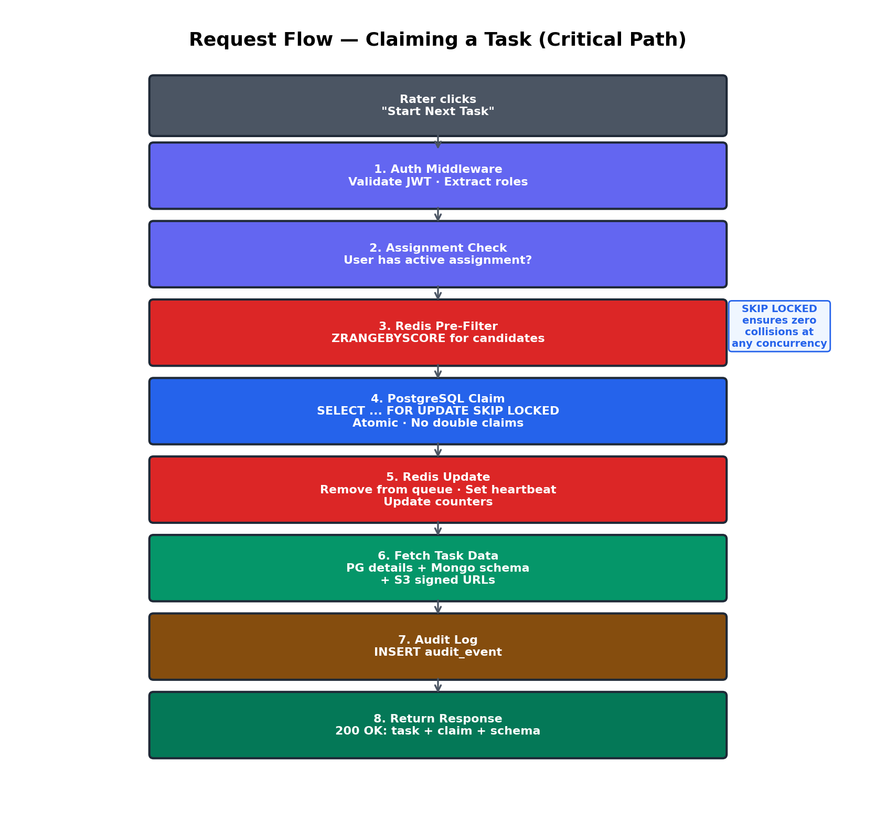
Detailed step-by-step flow when a rater clicks "Start Next Task":
POST /api/v1/queue/next
Body: { batchId: "optional" }
Header: Authorization: Bearer <jwt>

1. AUTH MIDDLEWARE
-> Validate JWT from Redis session store
-> Extract userId, roles from token
-> Verify user has 'rater' role

2. ASSIGNMENT CHECK
-> Query: does this user have an active assignment for any batch?
-> If no assignments -> 404 "No tasks available"

3. REDIS PRE-FILTER (fast path)
-> Check Redis sorted sets for user's assigned batches
-> ZRANGEBYSCORE queue:{batch}:{stage} -inf +inf LIMIT 0 10
-> Get list of candidate task IDs
-> If Redis empty, fall back to PostgreSQL directly

4. POSTGRESQL CLAIM (atomic, safe)
-> BEGIN TRANSACTION
-> SELECT id FROM tasks
WHERE batch_id IN (assigned_batches)
AND pipeline_stage = current_stage
AND status = 'pending' AND deleted_at IS NULL
ORDER BY uploaded_at ASC LIMIT 1
FOR UPDATE SKIP LOCKED; <-- NO DOUBLE CLAIM
-> If no task -> ROLLBACK -> 404
-> UPDATE tasks SET status = 'claimed' WHERE id = task_id;
-> INSERT INTO task_claims (...) VALUES (...);
-> COMMIT

5. REDIS UPDATE
-> ZREM queue:{batch}:{stage} task_id (remove from cache)
-> SET heartbeat:{claim_id} NOW() EX 300
-> HINCRBY project_counts:{project_id} claimed 1
-> HINCRBY project_counts:{project_id} pending -1

6. FETCH TASK DATA
-> Get task details from PG (media_keys, task_data)
-> Get response schema from MongoDB
-> Generate signed S3 URLs for each media file

7. AUDIT LOG -> INSERT audit_event: { type: 'task_claimed', ... }

8. RETURN 200 OK: { task, claim, schema, mediaUrls }

7. Frontend Architecture

7.1 Technology Decisions
Choice | Library | Rationale
Framework | React 18+ | Client-mandated
Type safety | TypeScript (strict) | Prevents runtime errors, shared types with backend
Styling | Tailwind CSS + shadcn/ui | Professional design system, no designer dependency
State management | React Query (TanStack) | Server state caching, auto-refetch, optimistic updates
Form management | react-hook-form | Performant forms, recursive schema renderer compatible
Routing | React Router v6 | Nested route support
Image zoom | react-zoom-pan-pinch | Smooth zoom/pan for annotation images
Audio | wavesurfer.js | Waveform visualization, seek, speed control
Video | HTML5 <video> + custom | Byte-range seeking for 500MB files
HTML render | DOMPurify | XSS-safe HTML rendering
Build | Vite | Fast dev server, optimized production builds
Testing | Playwright + Vitest | E2E + unit, CI-integrated

7.2 Portal Isolation Model
Three separate React applications ensure security by architecture. No portal contains code from another persona. This is not just UI hiding — it is a physical code boundary.
Portal | Accessible To | Contains | Bundle Size
web-ops | Admin, Ops | Project config, pipeline builder, task mgmt, user mgmt, upload, export, linter, benchmark, audit | ~800 KB
web-rater | Rater, Reviewer | Task queue, Task UI (media + schema forms), submission, benchmarks, linter feedback | ~500 KB
web-customer | Customer | Dashboard, seat management, API key view, usage metrics | ~200 KB

8. Schema-Driven Task UI Engine
This is the most complex frontend component in the entire platform. The Task UI renders a split-pane layout: a Media Panel on the left showing task content, and a Response Panel on the right with a schema-driven dynamic form. The form engine recursively walks a JSON Schema tree with custom x-ui-* extensions to render conditional fields, repeater sections, and nested object groups.

8.1 Architecture Overview
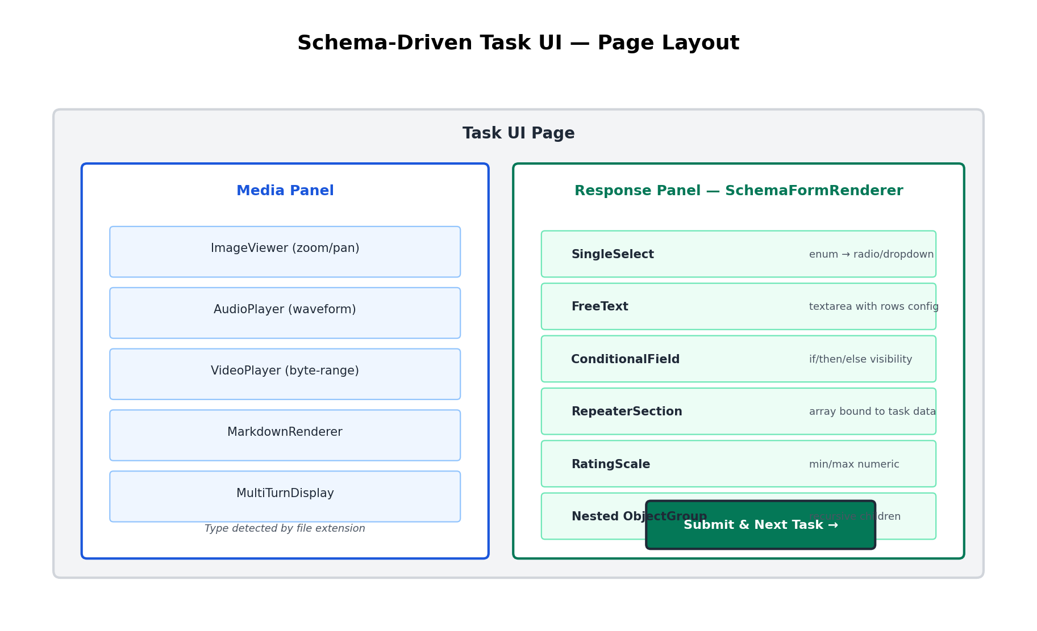

8.2 Schema Rendering Logic (Full Pseudocode)
The recursive renderer walks the JSON Schema tree. Full TypeScript pseudocode:
// packages/schema-engine/src/renderer.ts

function renderSchemaNode(
node: SchemaNode, path: string,
formState: FormState, taskData: TaskData
): ReactElement {

// Step 1: Check conditional visibility
if (node['x-ui-condition']) {
const condition = node['x-ui-condition'];
const dependentValue = getFormValue(formState, condition.field);
const isVisible = evaluateCondition(dependentValue, condition.operator, condition.value);
if (!isVisible) return null; // field hidden
}

// Step 2: Check pipeline-level visibility
if (node['x-ui-visibility']) {
const currentStage = getCurrentPipelineStage();
if (!node['x-ui-visibility'].includes(currentStage)) return null;
}

// Step 3: Render based on type
switch (node['x-ui-component']) {
case 'single-select':
return <SingleSelectField path={path} options={node.enum} label={node['x-ui-label']} />;

case 'multi-select':
return <MultiSelectField path={path} options={node.enum} label={node['x-ui-label']} />;

case 'free-text':
return <FreeTextField path={path} rows={node['x-ui-rows'] || 3} />;

case 'rating-scale':
return <RatingScaleField path={path} min={node.minimum} max={node.maximum} />;

case 'repeater':
// Bind to task data array
const sourceArray = getNestedValue(taskData, node['x-ui-repeat-source']);
return (
<RepeaterSection label={node['x-ui-label']}>
{sourceArray.map((item, index) => (
<RepeaterItem key={index} label={item[node['x-ui-repeat-label-field']]}>
{renderSchemaNode(node.items, path+'['+index+']', formState, taskData)}
</RepeaterItem>
))}
</RepeaterSection>
);

case undefined:
// Object type -- render children
if (node.type === 'object' && node.properties) {
const sortedProps = Object.entries(node.properties)
.sort(([,a], [,b]) => (a['x-ui-order'] || 0) - (b['x-ui-order'] || 0));
return (
<FieldGroup>
{sortedProps.map(([key, child]) =>
renderSchemaNode(child, path+'.'+key, formState, taskData)
)}
</FieldGroup>
);
}
}
}

8.3 Example Schema with Conditions + Repeaters
{
"type": "object",
"properties": {
"overall_quality": {
"type": "string", "enum": ["good", "bad"],
"x-ui-component": "single-select"
},
"rejection_reason": {
"type": "string", "x-ui-component": "free-text",
"x-ui-condition": { "field": "overall_quality", "equals": "bad" }
// ↑ Only shown when quality == "bad"
},
"turns": {
"type": "array", "x-ui-component": "repeater",
"x-ui-repeat-source": "task.data.conversation_turns",
// ↑ Renders one section per conversation turn from task data
"items": {
"type": "object",
"properties": {
"turn_rating": { "type": "string", "enum": ["helpful", "not_helpful"] },
"turn_feedback": { "type": "string", "x-ui-component": "free-text" }
}
}
}
}
}

8.4 Validation Flow
Annotation validation happens in two stages:
- Frontend: react-hook-form validates required fields, ajv validates against JSON Schema, hidden conditional fields are stripped, repeater arrays validated per-item.
- Backend: Re-validate with ajv (never trust client), run linters (response_length, required_fields, response_time). Blocking linters return 422; warnings are stored but allowed.

9. Pipeline Engine — Deep Dive
The pipeline engine is a configurable state machine that governs how tasks flow through annotation stages. Each project defines its own pipeline configuration (stored in MongoDB) specifying stages, allowed transitions, and auto-advance rules.

9.1 State Machine
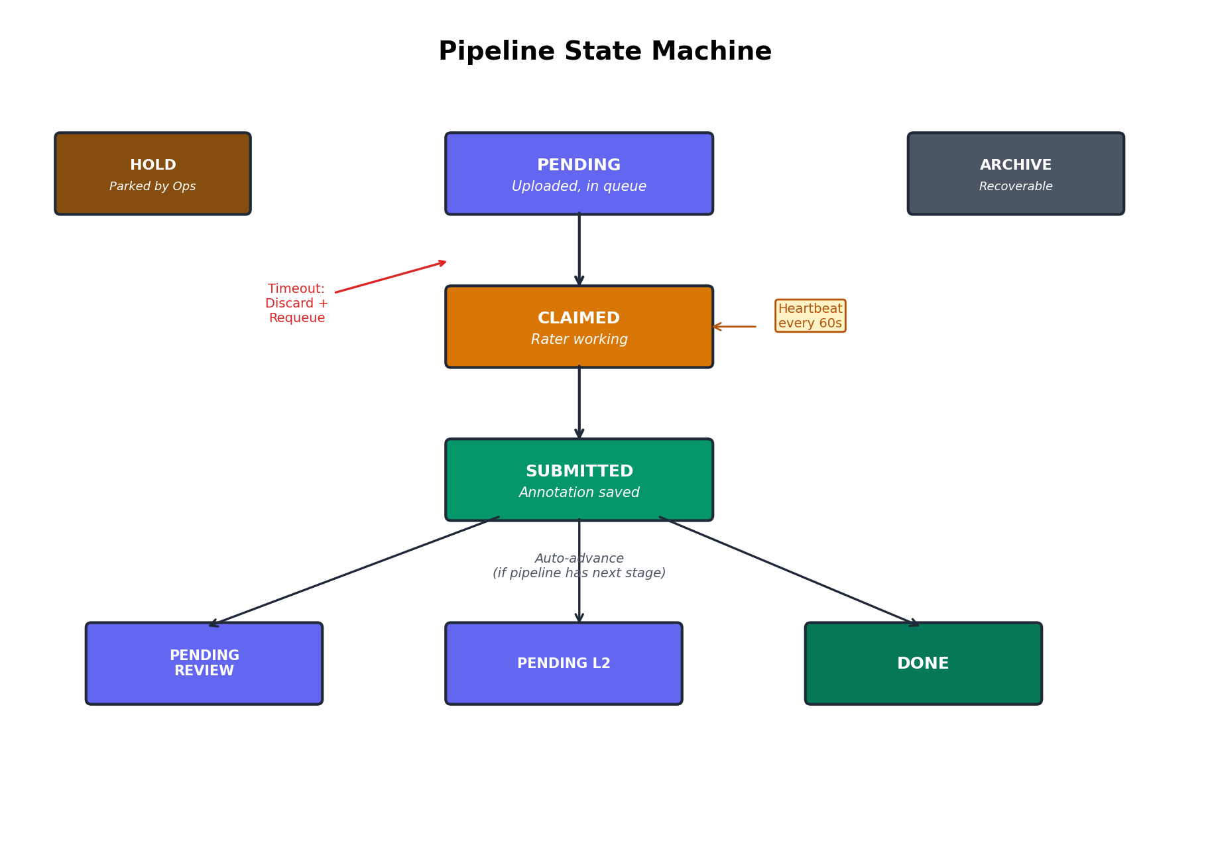

9.2 Pipeline Stage Types
Type | Examples | Behavior
annotation | L1, L2 | Rater claims task, fills form, submits annotation
review | QA Review | Reviewer sees original task + prior annotations, makes approve/reject/revise decision
system | Hold, Archive | Ops manually parks or archives tasks. Recoverable.
terminal | Done, Delivered | Final state. Task is complete.

9.3 Pipeline Transition Logic (TypeScript)
// packages/pipeline-engine/src/state-machine.ts

class PipelineStateMachine {
constructor(private config: PipelineConfig) {}

canTransition(from: string, to: string): boolean {
const rule = this.config.transitions.find(t => t.from === from);
if (!rule) return false;
return rule.to.includes(to);
}

getNextStage(currentStage: string): string | null {
const current = this.config.stages.find(s => s.id === currentStage);
if (!current || !current.autoAdvance) return null;

const sorted = this.config.stages
.filter(s => s.type !== 'system' && s.type !== 'terminal')
.sort((a, b) => a.order - b.order);

const currentIndex = sorted.findIndex(s => s.id === currentStage);
if (currentIndex === -1 || currentIndex === sorted.length - 1) {
return 'done'; // No more annotation/review stages
}
return sorted[currentIndex + 1].id;
}

requiresConsensus(stage: string): boolean {
const stageConfig = this.config.stages.find(s => s.id === stage);
return (stageConfig?.consensusN || 1) > 1;
}
}

9.4 Transition Rules
From | Allowed To | Triggered By
L1 | L2, Hold, Archive | Auto-advance on submit (to L2) or Ops manual action
L2 | Review, Hold, Archive | Auto-advance on submit (to Review) or Ops
Review | Done, L1, Hold | Approve → Done, Reject → back to L1, or Hold
Hold | L1, L2, Review, Archive | Ops manually returns to any stage
Done | Delivered | Export/delivery trigger

10. Queue & Claim Locking — Deep Dive

10.1 The Problem
At 100K tasks/day with 800 concurrent raters, the queue system must:
- Serve the correct next task (FIFO order) to each rater
- Never serve the same task to two raters simultaneously
- Handle 100+ claim requests per second at peak
- Release abandoned tasks back to the queue within 3 minutes
- Respect assignment boundaries (only serve tasks from assigned batches)

10.2 The Solution: PostgreSQL SKIP LOCKED
The core claim operation uses PostgreSQL's SELECT ... FOR UPDATE SKIP LOCKED. This ensures that if two transactions try to claim the same row simultaneously, the second transaction skips the locked row and claims the next available one. Zero collisions, zero deadlocks, deterministic FIFO ordering.
BEGIN;
-- Find next eligible task (SKIP LOCKED = no waiting, no double claims)
SELECT id INTO next_task_id FROM tasks
WHERE batch_id = ANY($assigned_batch_ids)
AND pipeline_stage = $current_stage
AND status = 'pending'
AND deleted_at IS NULL
ORDER BY uploaded_at ASC
LIMIT 1
FOR UPDATE SKIP LOCKED;

-- Claim it
UPDATE tasks SET status = 'claimed' WHERE id = next_task_id;
INSERT INTO task_claims (task_id, user_id, ...) VALUES (...);
COMMIT;

10.3 Claim Lifecycle
Event | Result | Details
Rater submits annotation | COMPLETED | Task advances to next pipeline stage
Rater clicks "Release" | RELEASED | Task returns to pending, available for others
No heartbeat for 3 min | EXPIRED (cron job) | Partial work discarded, task requeued
Hard timeout (30 min) | EXPIRED | Absolute deadline, task requeued

10.4 Claim Cleanup Cron Job
-- Cron job runs every 60 seconds (BullMQ repeatable job):

UPDATE task_claims SET status = 'expired'
WHERE status = 'active'
AND last_heartbeat < NOW() - INTERVAL '3 minutes'
RETURNING task_id;

-- For each expired claim:
UPDATE tasks SET status = 'pending' WHERE id = expired_task_id;
-- Remove from Redis heartbeat cache
-- Log audit event: { type: 'claim_expired', taskId, userId }
Why SKIP LOCKED is deterministic: If Rater A and Rater B both call /queue/next at the exact same millisecond: Rater A's transaction locks row 1 (FOR UPDATE). Rater B's transaction sees row 1 is locked, SKIPS it, locks row 2. Result: Rater A gets task 1, Rater B gets task 2. Zero collisions. Zero waiting. This works at any concurrency level without deadlocks.

11. Media Handling — Upload, Storage & Rendering

11.1 Supported Media Types
Type | Formats | Max Size | Rendering
Image | JPEG, PNG, WebP, GIF, TIFF | 500 MB | react-zoom-pan-pinch (zoom/pan/rotate)
Audio | MP3, WAV, FLAC, OGG, M4A | 500 MB | wavesurfer.js (waveform + seek + speed)
Video | MP4, WebM, MOV | 500 MB | HTML5 <video> with byte-range seeking
Text | Plain text | 5 MB | <pre> or monospace render
Markdown | .md | 5 MB | react-markdown with syntax highlighting
HTML | .html | 5 MB | DOMPurify-sanitized iframe render
PDF | .pdf | 50 MB | react-pdf viewer

11.2 Upload & Serving Flow
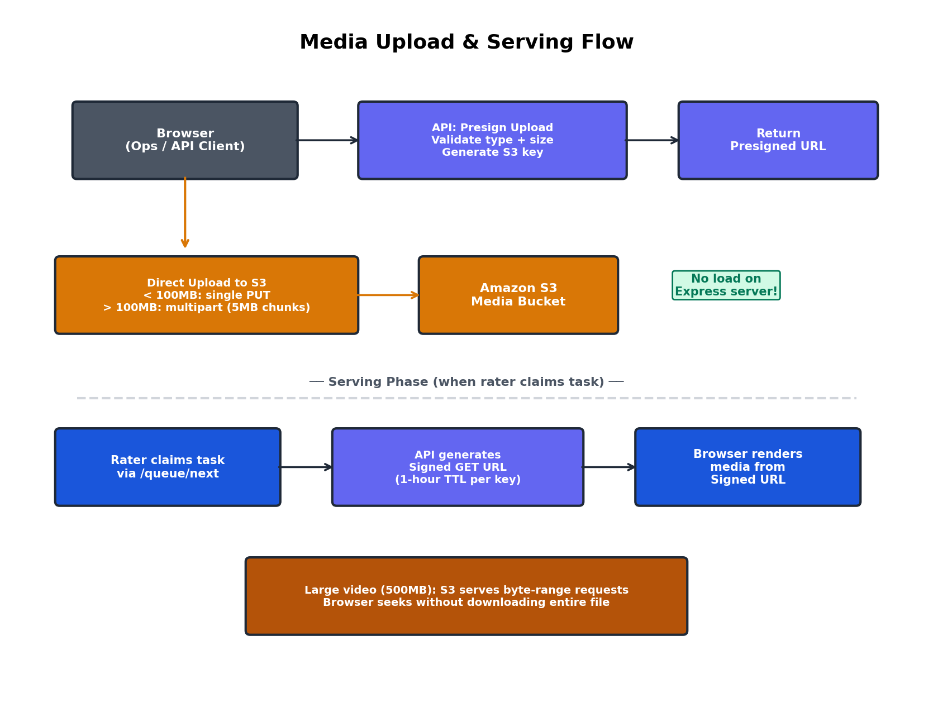
Key design decisions for media handling:
- Direct upload: Uploads go directly from browser to S3 via presigned PUT URLs -- zero load on Express server.
- Multipart: Files > 100MB use S3 multipart upload with 5MB chunks for progress tracking and resume on failure.
- Signed URLs: Signed GET URLs have 1-hour TTL. Each URL is per-user, per-task.
- Byte-range: S3 supports HTTP Range headers. Video players seek to any position without downloading the full file.
- Type detection: File extension determines the renderer component (image/audio/video/markdown/html/pdf).

11.3 Media Type Detection & Rendering (TypeScript)
// apps/web-rater/src/components/media/MediaRenderer.tsx

function MediaRenderer({ mediaKeys, signedUrls }: Props) {
return (
<>
{mediaKeys.map((key, i) => {
const url = signedUrls[key];
const ext = key.split('.').pop()?.toLowerCase();
const type = detectMediaType(ext);

switch (type) {
case 'image':
return <ZoomableImage key={i} src={url} />;
// react-zoom-pan-pinch: scroll to zoom, drag to pan
// Lazy-loads: only fetches image when visible

case 'audio':
return <WaveformAudioPlayer key={i} src={url} />;
// wavesurfer.js: visual waveform, click-to-seek
// Playback speed: 0.5x, 1x, 1.5x, 2x

case 'video':
return <VideoPlayer key={i} src={url} />;
// HTML5 <video> with custom controls
// Byte-range seeking (S3 supports Range headers)
// For 500MB files, browser streams -- never downloads fully

case 'markdown':
return <MarkdownViewer key={i} src={url} />;
case 'html':
return <SanitizedHtmlViewer key={i} src={url} />;
case 'pdf':
return <PdfViewer key={i} src={url} />;
default:
return <FileDownloadLink key={i} src={url} filename={key} />;
}
})}
</>
);
}

function detectMediaType(ext: string): MediaType {
const map: Record<string, MediaType> = {
jpg: 'image', jpeg: 'image', png: 'image', webp: 'image',
gif: 'image', tiff: 'image',
mp3: 'audio', wav: 'audio', flac: 'audio', ogg: 'audio', m4a: 'audio',
mp4: 'video', webm: 'video', mov: 'video',
md: 'markdown', html: 'html', htm: 'html', pdf: 'pdf', txt: 'text',
};
return map[ext] || 'unknown';
}

12. Authentication & Authorization

12.1 Auth Strategy — Adapter Pattern
Authentication uses an adapter interface (IAuthProvider) allowing seamless migration from Phase 1 (JWT + bcrypt + PostgreSQL) to Phase 2 (Okta OAuth2 PKCE) via a configuration change.
interface IAuthProvider {
authenticate(credentials): Promise<AuthResult>;
validateToken(token): Promise<UserSession>;
refreshToken(refreshToken): Promise<AuthResult>;
logout(sessionId): Promise<void>;
}
// Phase 1: LocalAuthProvider (JWT + bcrypt)
// Phase 2: OktaAuthProvider (OAuth2 PKCE + Okta SDK)

12.2 Phase 1 Auth Flow
Login: Email + password → bcrypt compare → JWT access token (15 min) + refresh token (7 day) → stored in Redis + HTTP-only cookie.
Validation: Every request → extract Bearer token → check Redis cache (fast path) → if miss, verify JWT (slow path) → attach user to request context.

12.3 RBAC Permission Matrix
Permission | Admin | Ops | Rater | Reviewer | Customer
project.create | ✓ | ✓ | — | — | —
project.read | ✓ | ✓ | — | — | —
task.claim | — | — | ✓ | ✓ | —
annotation.submit | — | — | ✓ | ✓ | —
batch.export | ✓ | ✓ | — | — | —
user.manage | ✓ | — | — | — | —
customer.dashboard | — | — | — | — | ✓
impersonation | ✓ | — | — | — | —

12.4 RBAC Middleware (TypeScript)
// apps/api/src/middleware/rbac.ts

const PERMISSIONS = {
// Resource admin ops rater reviewer customer
'project.create': [ true, true, false, false, false ],
'project.read': [ true, true, false, false, false ],
'task.claim': [ false, false, true, true, false ],
'task.advance': [ true, true, false, false, false ],
'annotation.submit': [ false, false, true, true, false ],
'batch.export': [ true, true, false, false, false ],
'user.manage': [ true, false, false, false, false ],
'customer.dashboard': [ false, false, false, false, true ],
'impersonation.start': [ true, false, false, false, false ],
};

function requirePermission(permission: string) {
return (req, res, next) => {
const userRole = req.user.role;

// Check global permission
if (!PERMISSIONS[permission]?.[roleIndex(userRole)]) {
return res.status(403).json({
error: { code: 'FORBIDDEN', message: 'Insufficient permissions' }
});
}

// Check resource scope (rater can only access assigned projects)
if (permission.startsWith('task.') && userRole === 'rater') {
// Verify rater is assigned to the batch/project containing this task
}
next();
};
}

// Applied on routes:
router.post('/projects', requirePermission('project.create'), createProject);
router.post('/queue/next', requirePermission('task.claim'), claimNextTask);
Permissions are enforced server-side via middleware. Resource-scoped checks ensure raters can only access tasks from their assigned batches/projects.

13. Security Architecture
Security is implemented as defense in depth across seven layers, from network isolation to audit compliance. Each layer operates independently — a failure in one layer does not compromise the entire system.
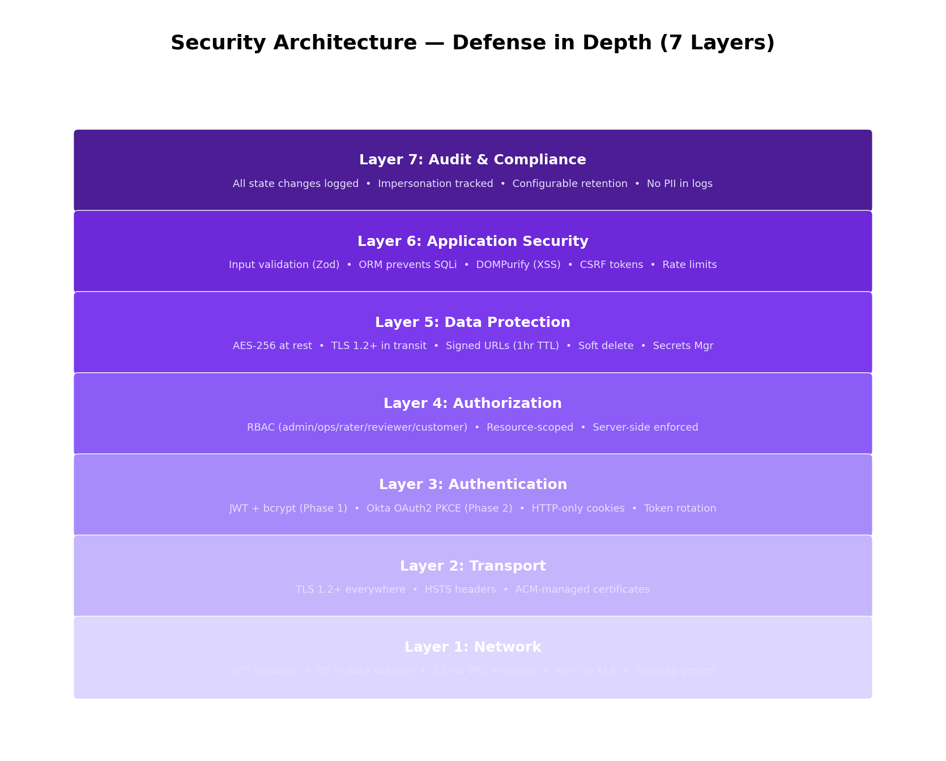

13.1 Layer Details
Layer 1 — Network: VPC with three-tier subnets. Databases in isolated data subnets with no internet. S3 via VPC Gateway Endpoint. ALB with WAF rules. Security groups restrict API → DB only.
Layer 2 — Transport: TLS 1.2+ enforced on all connections (ALB, S3, DB). HSTS header on all responses. Certificates managed by ACM with auto-renewal.
Layer 3 — Authentication: Phase 1: JWT + bcrypt-hashed passwords. Phase 2: Okta OAuth2 PKCE. HTTP-only, Secure, SameSite=Strict cookies. Refresh token rotation on use.
Layer 4 — Authorization: RBAC with 5 roles (admin, ops, rater, reviewer, customer). Resource-scoped per workspace/project/batch. Server-side enforcement. Separate frontend bundles.
Layer 5 — Data Protection: AES-256 encryption at rest (RDS, DocumentDB, S3, Redis). TLS in transit. S3 signed URLs with 1-hour TTL. Soft delete preserves audit trail. Secrets in AWS Secrets Manager.
Layer 6 — Application: Input validation (Zod) on every endpoint. Prisma ORM prevents SQL injection. DOMPurify for XSS. CSRF tokens. Rate limiting per-IP/per-user. npm audit + Dependabot in CI.
Layer 7 — Audit & Compliance: All state changes logged with actor, timestamp, before/after. Impersonation sessions explicitly tracked. Configurable retention. No PII in logs (user IDs only).

14. Performance & Scalability

14.1 Performance Budget
Operation | Target (p95) | How We Achieve It
Page load (SPA) | < 2s | Code splitting, lazy loading, CDN for static assets
API: CRUD operations | < 200ms | PostgreSQL indexes, connection pooling (PgBouncer)
API: Claim next task | < 100ms | SKIP LOCKED + Redis pre-filter
API: Submit annotation | < 300ms | MongoDB write + PG status update + Redis invalidation
Bulk upload (10K tasks) | < 120s | Streaming NDJSON parser, batched PG inserts (500/batch)
Batch export (5K tasks) | < 60s | Background worker, parallel S3 signed URL generation
Dashboard load | < 500ms | Redis cached counters, not live COUNT(*) queries

14.2 Scaling Strategy
Scale math: 100K tasks/day ≈ 1.2 tasks/sec avg. 150K peak ≈ 4.2 tasks/sec (10-hr window). 800 concurrent raters ≈ 13 claims/sec at peak.
API Layer: Stateless Express instances behind ALB. Auto-scale 2→6 based on CPU > 60%. Each instance handles ~200 concurrent connections. PgBouncer pools 100 connections.
PostgreSQL: Primary handles all writes. Read replica for dashboard queries (eventual consistency OK). Queue reads go to primary (consistency critical). Audit events partitioned by month.
Redis: Queue sorted sets O(log N). Counters O(1). Sessions O(1). ~500MB memory for 100K active tasks. ElastiCache cache.r6g.large (13 GB) provides ample headroom.
MongoDB: ~150K annotations/day. Document size 1-50 KB. Daily storage growth 3-7 GB. Sharding not needed until >1M tasks/day.

15. Background Job Architecture
Long-running operations (bulk upload, export, cleanup) run as background jobs using BullMQ with Redis as the backing store. Jobs are persistent, retryable, and observable.
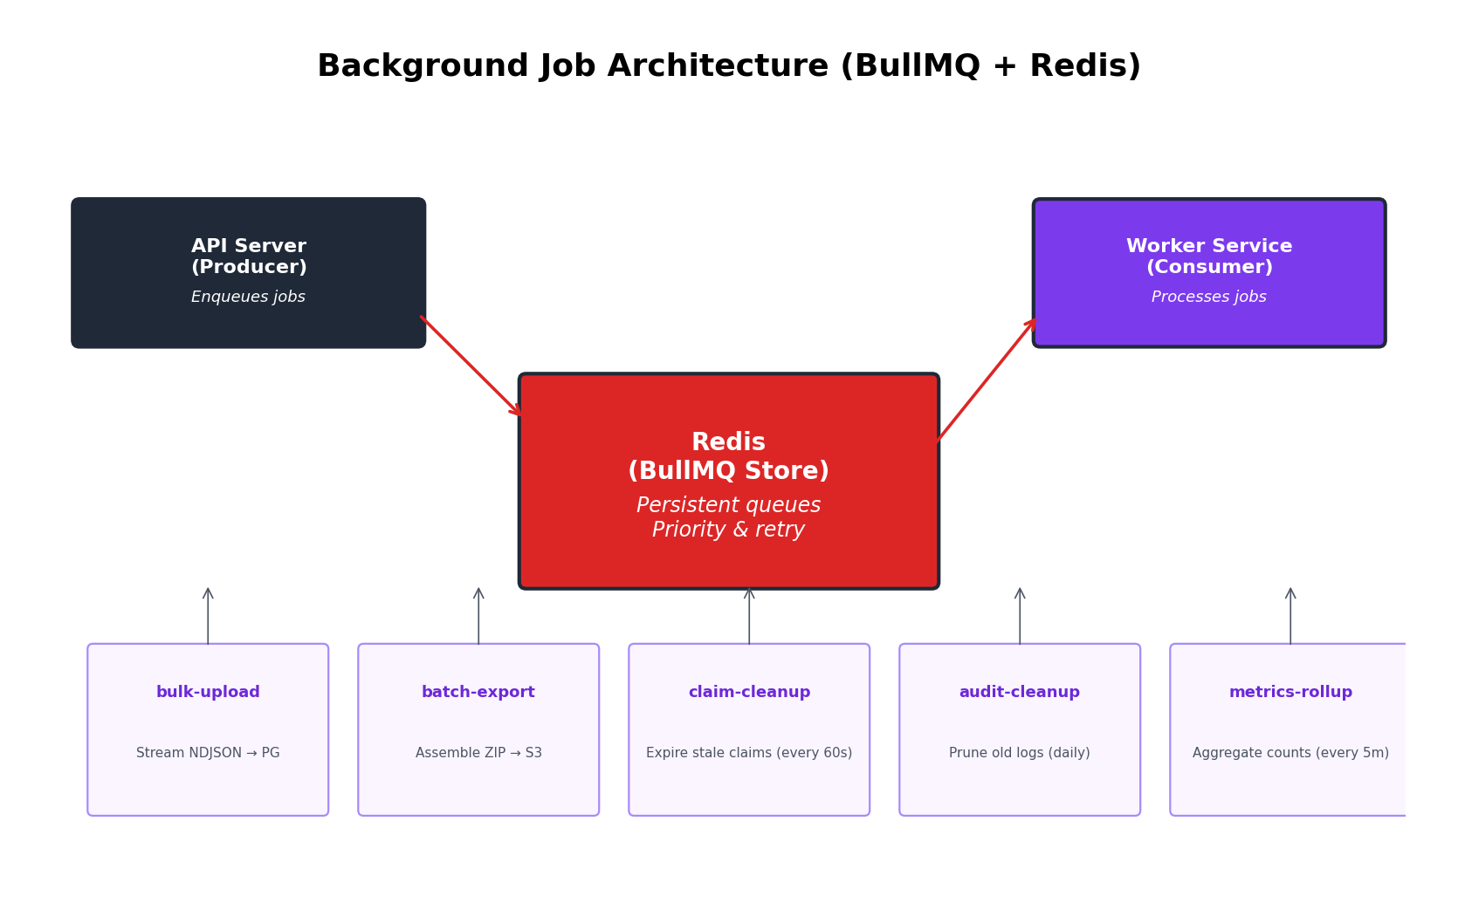

15.1 Job Types
Job | Trigger | Frequency | Details
bulk-upload | POST /batches/:id/upload | On-demand | Stream NDJSON → validate → batch INSERT into PG (500/batch). Memory: ~50MB regardless of file size.
batch-export | POST /batches/:id/export | On-demand | Query annotations → generate CSV/JSON → ZIP → upload to S3 → return signed URL.
claim-cleanup | Automatic (BullMQ repeatable) | Every 60 seconds | Find claims with stale heartbeats (> 3 min), expire them, requeue tasks.
audit-cleanup | Automatic (BullMQ repeatable) | Daily | Delete audit events older than configured retention (default 15 days).
metrics-rollup | Automatic (BullMQ repeatable) | Every 5 minutes | Aggregate task counts and sync Redis counters with actual PG counts.

15.2 BullMQ Queue Setup (TypeScript)
// BullMQ uses Redis as its backing store
// All jobs are persistent, retryable, and observable

const queues = {
'bulk-upload': new Queue('bulk-upload', { connection: redis }),
'batch-export': new Queue('batch-export', { connection: redis }),
'claim-cleanup': new Queue('claim-cleanup', { connection: redis }), // repeatable: every 60s
'audit-cleanup': new Queue('audit-cleanup', { connection: redis }), // repeatable: daily
'metrics-rollup': new Queue('metrics-rollup', { connection: redis }), // repeatable: every 5 min
};

15.3 Bulk Upload — Streaming Architecture
NDJSON file (potentially millions of lines)
|
v
Worker: bulk-upload processor

1. Download file from S3 staging bucket (streaming, not full load)

2. Create a readline stream (process line by line)
-> NEVER loads entire file into memory
-> Backpressure: pauses reading if processing is slow

3. For each line:
a. Parse JSON
b. Validate against project's task upload schema
c. If valid -> add to insert buffer (batch of 500)
d. If invalid -> add to error list

4. When buffer reaches 500:
-> Bulk INSERT into PostgreSQL (single query, 500 rows)
-> Update Redis queue sorted sets
-> Update progress counter in Redis
-> Report progress via SSE to frontend

5. After all lines processed:
-> Generate error report (JSON) -> upload to S3
-> Update job status to 'completed'
-> Update batch.task_count in PostgreSQL
-> Log audit event

Memory usage: ~50MB regardless of file size (streaming)
Speed: ~5,000 tasks/second (limited by PG bulk insert)

16. Logging, Audit & Observability

16.1 Structured Logging
All logs are structured JSON shipped to Datadog. Example log entry:
// Every log entry includes:
{
"timestamp": "2026-03-15T10:30:00.123Z",
"level": "info",
"service": "annotation-api",
"traceId": "abc123", // Datadog APM trace ID
"userId": "u_001", // who (never PII like email)
"action": "task.claimed",
"resourceType": "task",
"resourceId": "t_042",
"duration_ms": 45,
"metadata": {
"batchId": "b_007",
"pipelineStage": "l1"
}
}

16.2 Mandatory Audit Events
Event Type | Trigger | Details Captured
login / logout | Auth | User ID, IP, method (JWT/Okta)
task.claimed | Queue | Task ID, batch ID, pipeline stage, claim ID
annotation.submitted | Submit | Task ID, user ID, schema version, linter results
task.status_changed | Pipeline | From status, to status, triggered by (user/system)
batch.exported | Export | Batch ID, format, record count, file size
user.role_changed | Admin | User ID, old role, new role, granted by
impersonation.started | Admin | Impersonator ID, target user ID

16.3 Datadog Dashboards & Alerts
Four primary dashboards monitor system health:
- API Health: Request rate, error rate (5xx/total), latency p50/p95/p99, active connections.
- Queue Health: Tasks pending (by project), claims/min, collision rate (should be 0%), expired claims/hr.
- Rater Activity: Concurrent sessions, submissions/min, avg time per task, linter block rate.
- Infrastructure: RDS CPU/connections/IOPS/replication lag, DocumentDB ops/sec, Redis memory/hit rate, ECS CPU/memory.
Critical alerts:
- API error rate > 5% for 5 min → PagerDuty
- Queue depth > 10K for 15 min → Slack
- RDS CPU > 80% for 10 min → Slack
- Claim collision detected → PagerDuty (should never happen)
- Redis memory > 80% → Slack

17. CI/CD & Deployment Architecture

17.1 Pipeline
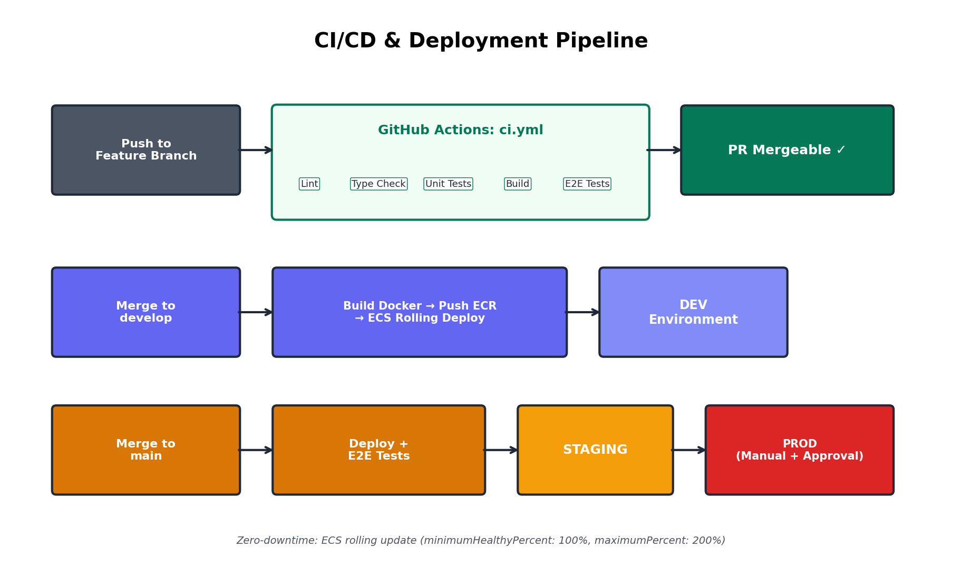

17.2 CI Steps (GitHub Actions)
Step | Tool | Purpose
1. Install | Turborepo (cached) | Fast dependency install with workspace caching
2. Lint | ESLint + Prettier | Code quality and formatting
3. Type check | TypeScript tsc | Compile-time type safety
4. Unit tests | Vitest | Module-level tests for business logic
5. Build | Turborepo | Build all apps and packages
6. E2E tests | Playwright | End-to-end tests against Docker test containers

17.3 Zero-Downtime Deployment
ECS rolling update strategy ensures zero downtime:
- minimumHealthyPercent: 100% — never drop below current capacity
- maximumPercent: 200% — allow 2x capacity during deploy
- New tasks (v2) launch alongside old tasks (v1)
- ALB health checks confirm v2 healthy, starts routing traffic
- v1 tasks are drained and stopped. Total downtime: 0 seconds.

17.4 Zero-Downtime Deployment Details
ECS Rolling Update Strategy:
minimumHealthyPercent: 100 # Never drop below current capacity
maximumPercent: 200 # Allow 2x capacity during deploy

1. ECS launches NEW tasks (v2) alongside OLD tasks (v1)
2. ALB health checks confirm v2 is healthy
3. ALB starts routing traffic to v2
4. Once all v2 tasks are healthy, v1 tasks are drained and stopped
5. Total downtime: 0 seconds

Database Migrations:
-> Run BEFORE deployment (migrate-then-deploy)
-> All migrations must be backward-compatible
-> No column drops in same release as code change
-> Two-step: (1) add column, deploy, (2) drop old column later

18. Disaster Recovery & Data Integrity

18.1 Backup Strategy
Component | Backup Method | RPO | RTO
PostgreSQL (RDS) | Automated daily snapshots + continuous PITR | 5 minutes | 30 minutes
DocumentDB | Automated daily snapshots | 24 hours | 1 hour
Redis (ElastiCache) | Not backed up (ephemeral cache) | N/A — rebuild from PG | 5 minutes
S3 | Versioning enabled, optional cross-region replication | 0 (immediate) | Instant

18.2 Data Integrity Guarantees
1. CLAIM INTEGRITY
-> PostgreSQL UNIQUE index ensures one active claim per task per stage
-> SKIP LOCKED prevents race conditions without deadlocks
-> If Redis is unavailable, system falls back to PG-only (slower, still correct)

2. ANNOTATION INTEGRITY
-> Annotation stored in MongoDB only after PG status update succeeds
-> If Mongo write fails: PG transaction rolls back, rater sees error, can retry
-> Response is validated against JSON Schema before storage (frontend + backend)

3. PIPELINE INTEGRITY
-> State machine validates every transition
-> Invalid transitions return 409 Conflict
-> All transitions logged in audit_events

4. FINANCIAL INTEGRITY (Time Tracking)
-> Time entries created on submit (not on claim) to avoid manipulation
-> Active time calculated from heartbeat log, not self-reported
-> Idle threshold: 2 minutes without interaction = idle (excluded from active time)

5. EXPORT INTEGRITY
-> Export jobs are idempotent (re-running produces same output)
-> Export includes checksum (SHA-256) for verification
-> Signed URLs in export are time-limited (24 hours)

This architecture document is the technical foundation for all engineering decisions. It should be reviewed and updated as the system evolves through each phase. All diagrams represent the target Phase 2 state unless otherwise noted.

